Subject: Fundamentals of Software Engineering (FSE)
Project Name: Merit-Swipe
Deliverable Number: D1 (Iteration 1 / Sprint 1)
Date of Submission: March 24, 2026
Group Members:
- Ahmad Azad – Roll No: 24L-2523
- Abdullah Aftab – Roll No: 24L-2553
- Abdul Muiz Mazhar – Roll No: 24L-2501

A. Project Title and Introduction
Project Title: Merit-Swipe
Introduction: Merit-Swipe is a comprehensive web application designed to aggregate, filter, and display credit card discount deals from various bank websites in Pakistan. It provides users with a centralized platform to discover the best restaurant and retail discounts available for their specific credit or debit cards.
For Sprint 1, our team focused on the foundational backend infrastructure. We established the core SQL Server database schema, created the initial Node.js/Express REST APIs to serve deal data, and built the Python-based ETL (Extract, Transform, Load) scraping pipeline to gather real-world discount data.
B. Sprint 1 Backlog & User Stories
Module Developed in Sprint 1: Core Data Pipeline and Backend Architecture
Selected User Stories:
- US-01 (Database): As a database administrator, I want to design and deploy the SQL database schema (banks, restaurants, deals) so the team has a centralized and relational data structure.
- US-02 (Data Scraper): As a data engineer, I want to scrape raw discount data from bank websites using Python so it can be formatted and loaded into our SQL database.
- US-03 (Backend API): As a backend developer, I want to set up an Express.js REST API connected to the SQL database so the frontend can retrieve paginated deal information.
C. Structured Specifications
(Below are the structured specifications for US-03: Backend API)
User Story: US-03 - Setup Deals REST API
Primary Actor: Frontend Client / React Application
Pre-conditions:
- The Microsoft SQL Server (merit_swipe database) is actively running on localhost.
- The deals, banks, and restaurants tables are populated with initial test data.
Post-conditions: 1. The client receives a JSON array of deal objects matching their search/filter criteria.
Main Success Scenario (Flow of Events):
- The client sends a GET request to the /deals endpoint with optional query parameters (search, bank, category, page, limit).
- The Express server validates the authentication token via the authenticateToken middleware.
- The server constructs a dynamic SQL query based on the provided filters.
- The server executes the query against the SQL Server using the mssql/msnodesqlv8 connection pool.
- The database returns the matching records and the total count for pagination.
- The server formats the response and sends a 200 OK status with the JSON data and pagination metadata.
Alternative Flows:
- Database Connection Failure: If the server cannot connect to SQL Server, it logs the error and returns a 500 Internal Server Error to the client.
D. Scrum Board & Burn-down Chart
Trello Snapshots:
- Snapshot 1 (Sprint Start): Showing the initial sprint backlog and planned user stories.
- 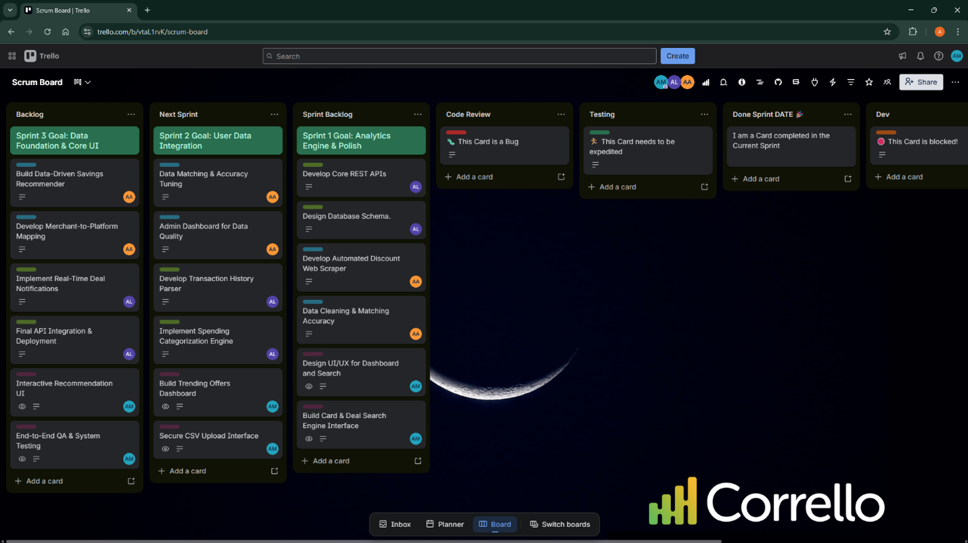Snapshot 2 (Mid-Sprint): Showing in-progress tasks like the SQL schema creation and Python loader.py script.
- 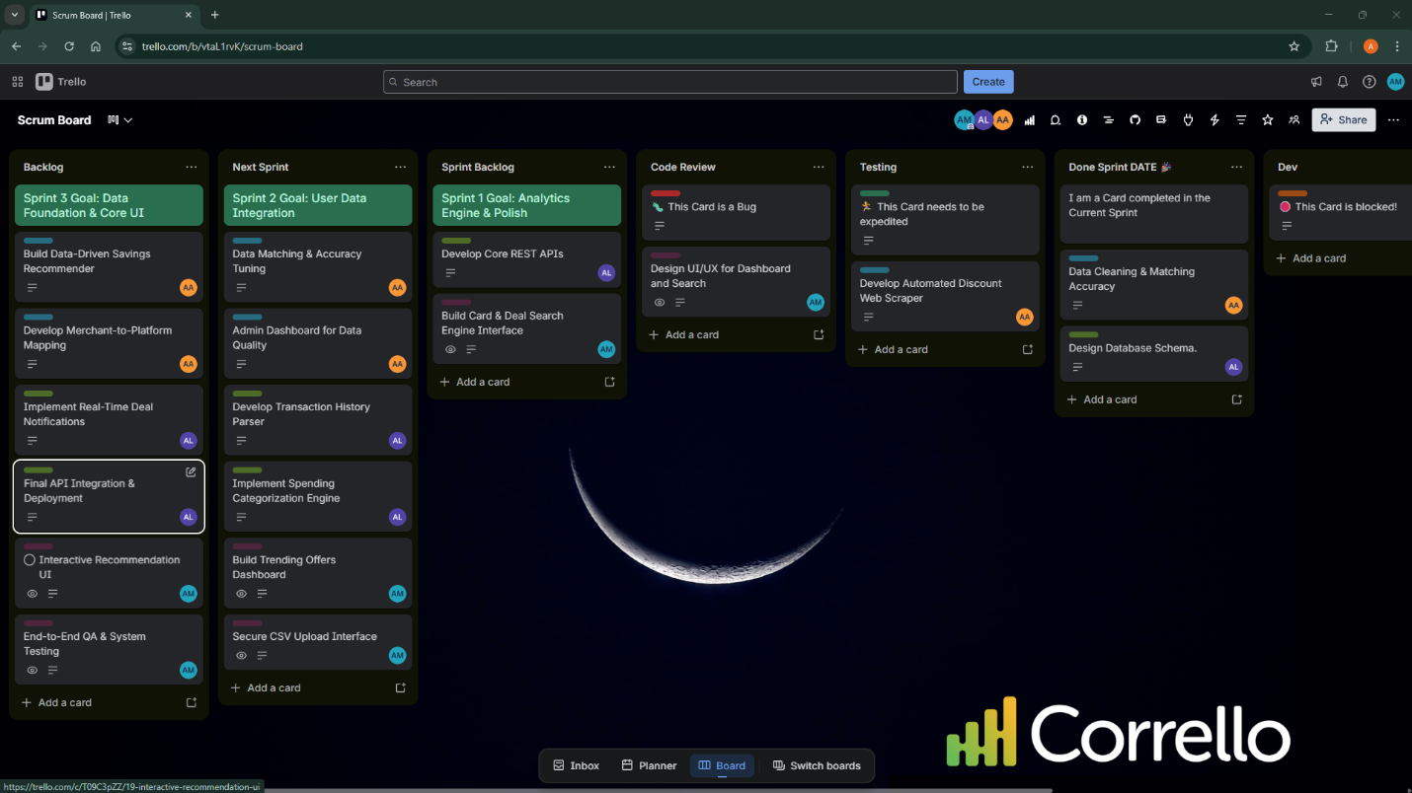Snapshot 3 (Sprint End): Showing completed tasks and any leftovers moved to Sprint 2.
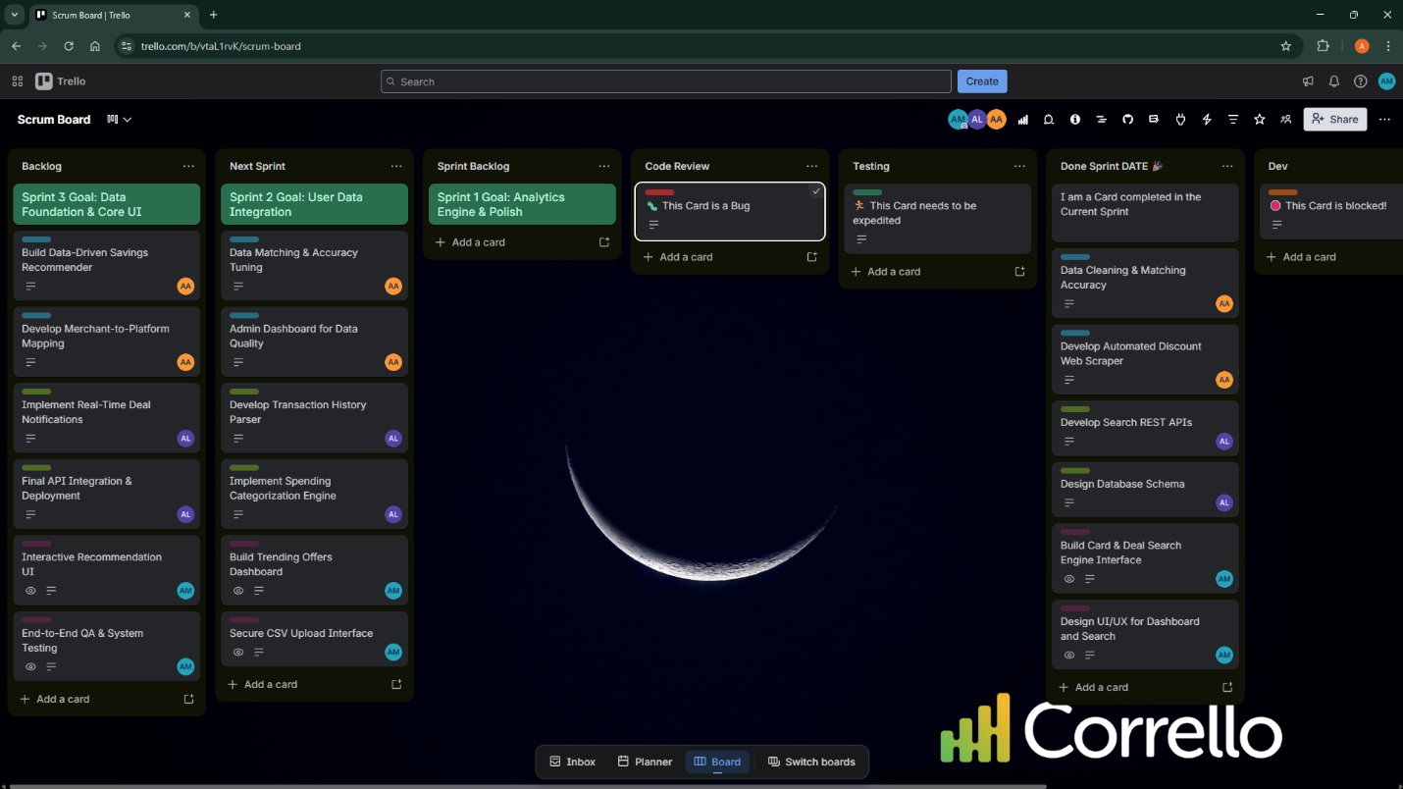Product Burn-down Chart:
Showing planned tasks versus completed tasks for Sprint 1.
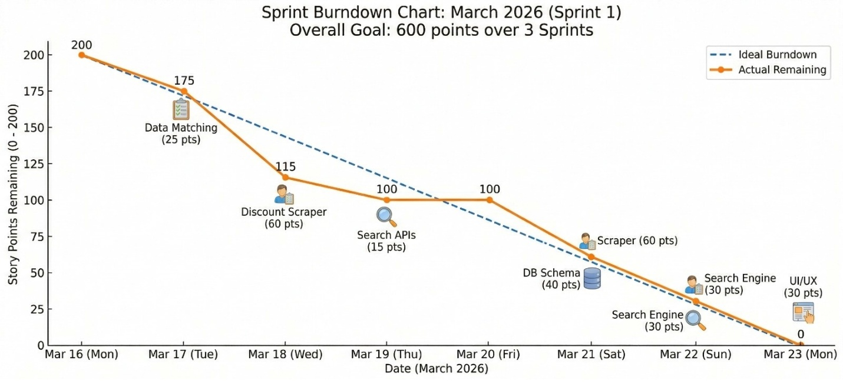E. Non-Functional Requirements (NFR) Specification
Written using natural language specification for the Sprint 1 module:
- Performance: The backend REST API /deals endpoint must return the JSON payload in under 500 milliseconds for a standard query to ensure a smooth user experience.
- Security: Local database connections must use encrypted protocols and trusted certificates (TrustServerCertificate=Yes) to prevent unauthorized access to the application data layer.
- Maintainability: All database schemas, backend scripts, and Python scrapers must be version-controlled using Git, with a centralized team repository on GitHub using standard branching conventions (e.g., docs/, feat/).
F. Iteration 1 Implementation Screenshots
- Database: 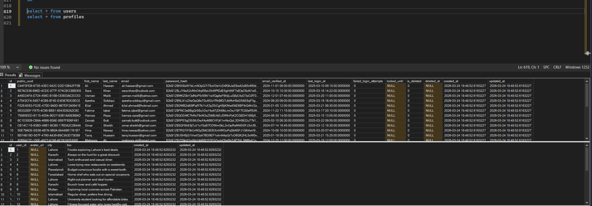
- Backend: 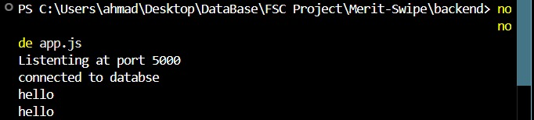Frontend: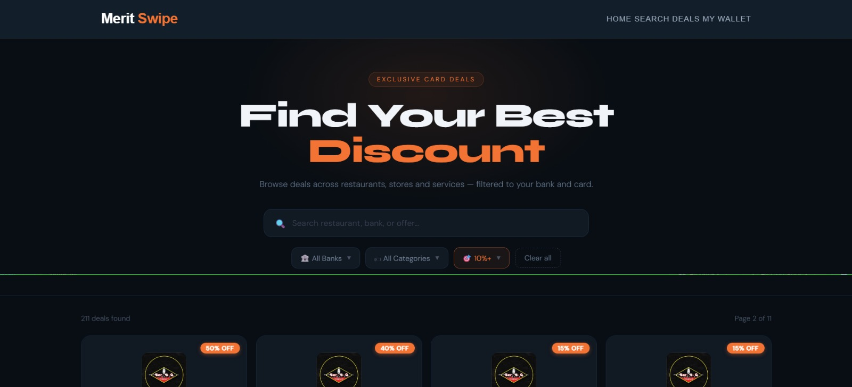
- GitHub: 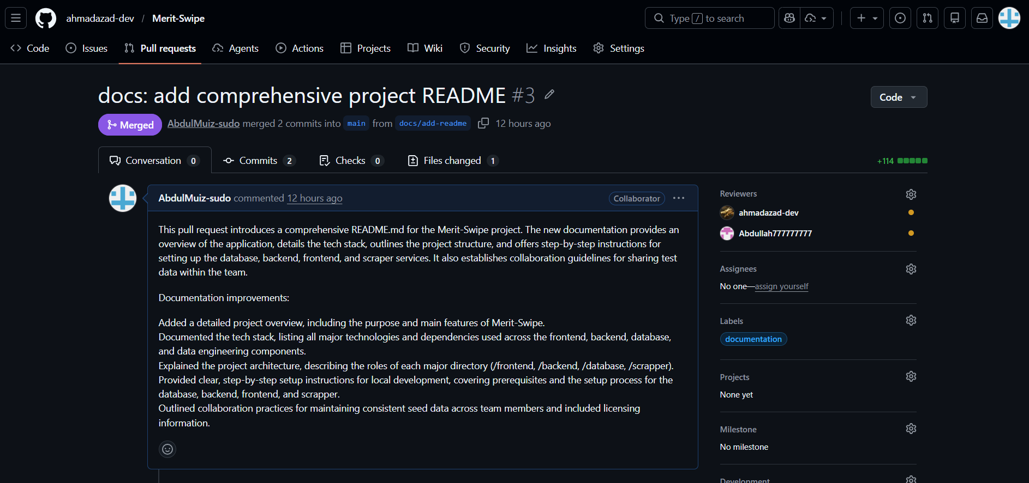
G. Work Division
- Ahmad Azad (Team Lead & Data Engineer): Managed project architecture, developed the web scraping scripts (loader.py, extractor.py), and ensured data quality/matching accuracy for Sprint 1.
- Abdullah Aftab (Backend & Database Developer): Designed the database schema (schema.sql), configured the local SQL Server, set up the Node.js/Express backend environment, and developed the initial REST APIs.
- Abdul Muiz Mazhar (Frontend Developer & QA): Focused on initial project documentation (README), Git version control management, and preparing the frontend environment for API integration and testing.

